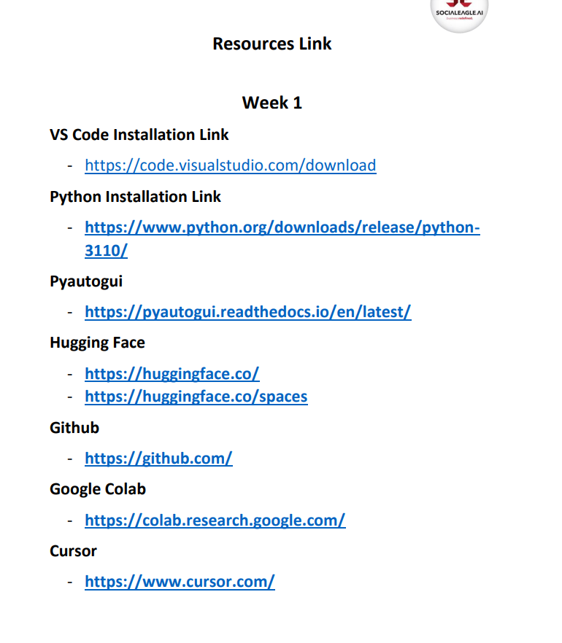

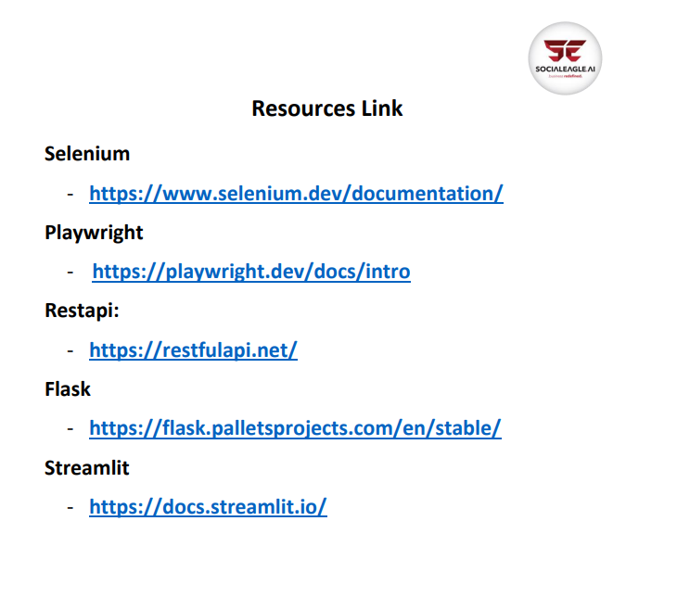

**Resources Link Week 1**

VS Code Installation Link - <https://code.visualstudio.com/download>

Python Installation Link - <https://www.python.org/downloads/release/python3110/>

Pyautogui - <https://pyautogui.readthedocs.io/en/latest/>

Hugging Face - <https://huggingface.co>

<https://huggingface.co/spaces>

Github - <https://github.com/>

Google Colab - <https://colab.research.google.com/>

Cursor - <https://www.cursor.com>

Selenium - <https://www.selenium.dev/documentation/>

Playwright - <https://playwright.dev/docs/intro>

Restapi: - <https://restfulapi.net/>

Flask - <https://flask.palletsprojects.com/en/stable/>

Streamlit - <https://docs.streamlit.io>